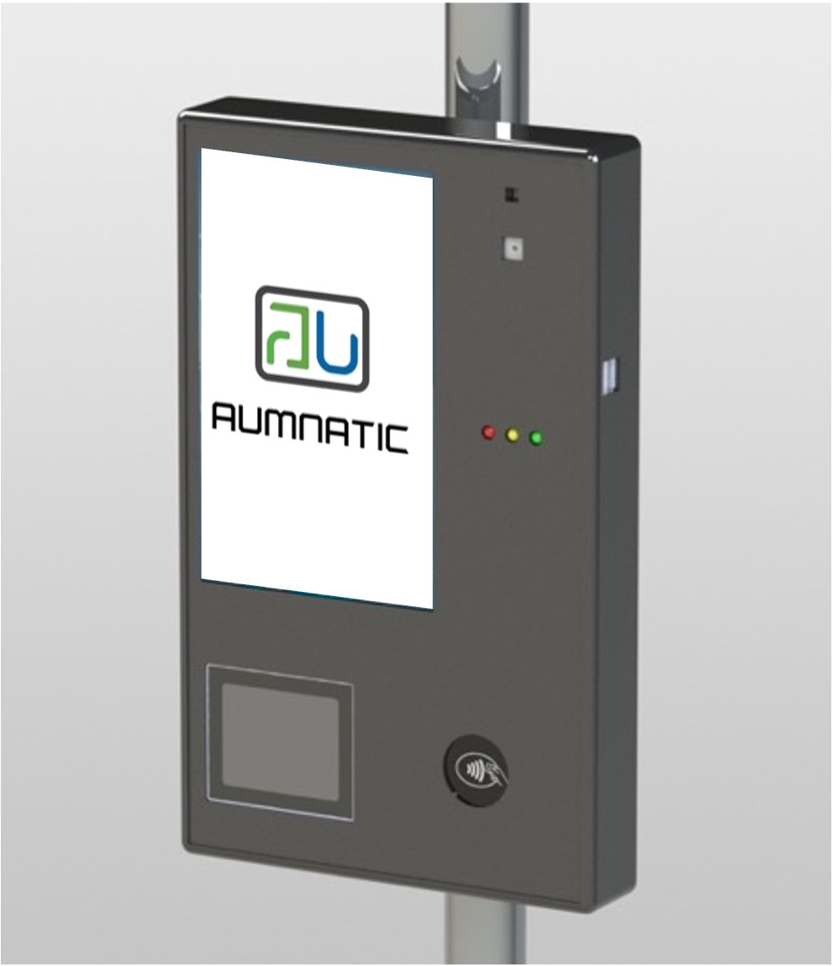

Fare Collection Bus Validator – AUVAL-B
- High Definition 7 Inch display

- Android Operating System

- Facial Detection

- Accepts Bank Cards / NFC Phone

- QR Code Reader

- In Built Battery

- Remote Device and Content Management
Product Datasheet – AUVAL-B Series
Connectivity Options
Connectivity over LAN, Wi-Fi or Bluetooth.
Secure communication channel for sensitive card data

Security Options
EMV certified hardware with support for Mastercard, Visa, RuPay, Amex and others

Integration Options
Designed to integrate with any Turnstile hardware designs and multiple AFCS system backend on standard integration protocols.
The validator comes with various customization options of size, material and form factor. You can choose to develop your own software on the validator or buy license software along with the hardware.

The software licensing options include
- QR Code issuance and validation software
- Open loop AFCS software license (Mastercard and Rupay NCMC [for India])
- NFC Access control license for Mifare / Desfire family
- Facial detection system APIs
AUVAL-B is Bus Transport Validator which can accept various forms of validation like Facial Detection, QR Code (Paper or Mobile), Smart Card, Smart Wearables, Smart Phones and Banking Cards.

It is suitable for Automatic Fare Collection System as well as building access control systems. The smart mechanical design helps the support executive achieve a very aggressive MTTR (Mean Time To Recovery) of less than 10 minutes. The special snap-in and snap-out feature helps the support executive to meet the Service Levels easily.
Product Datasheet – AUVAL-B
Dimension: 300 X 200 X 50 (mm)
Material – MS Powder coated
Validation Media: QR Code; Mastercard, Visa, Rupay, Mifare, Desfire
Mounting Provisions: Customized options available
Operating Temperature: -20°C to 60°C
Storage Temperature: -40°C to 70°C
Humidity: 5% to 95%, non-condensing
Operating System: Android 11 and above and Linux
Communication: Ethernet, WI-Fi, Bluetooth, USB, RS232
Active Screen Size: 7 inch Diagonal
QR Code Reader: 752X480 CMOS with 38.3mm X 60.4mm scan window

Specifications

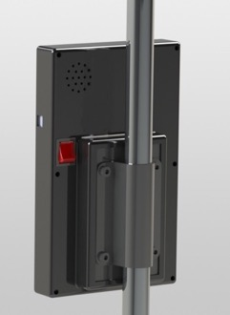
Installation Mechanism
SUPPORT AVAILABLE

Technical Support
Installation and Setup
Maintenance
Application Support
Hardware Support
Integration Support
Software Partners

