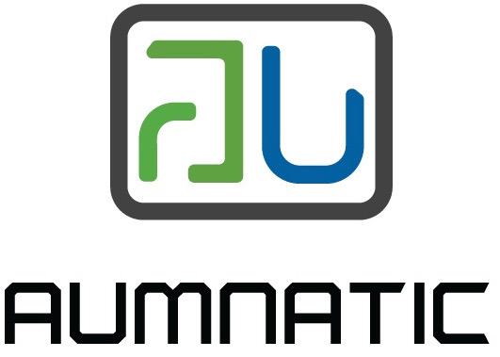


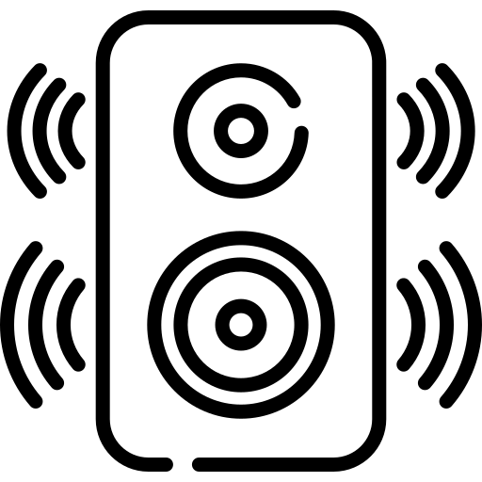
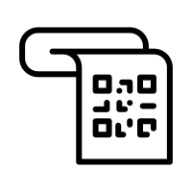
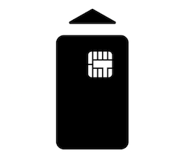



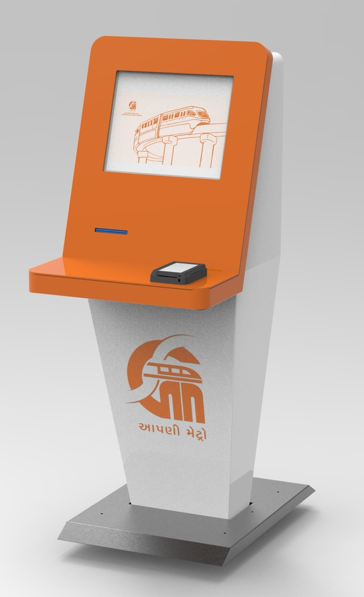
Connectivity Options
Connectivity over LAN and WiFi
Secure communication channel for sensitive card data

Security Options
EMV certified hardware with support for Mastercard, Visa, RuPay, Amex and others

Integration Options
Designed to integrate with any AFC backend system and device management system for Realtime device monitoring and updates.

Compliance
TUV Certified
IP52 certified
CISPR 11 for conducting and radiated emission
IEC 61000 for Conducted Immunity, EFT, Surge, ESD, Voltage dips & Interruptions, Power Frequency Magnetic Field and Radiated Susceptibility
The kiosk comes with various customization options of color and material. The maintenance panel is equipped easy to access with inbuilt maintenance lamp and an exhaust fan to keep the temperature inside the device optimal. As the device runs on android 11 operating system, developing software for the equipment becomes very fast and convenient. The software features which are possible using our APIs are
- Journey Planning
- Fare enquiry
- QR Code paper ticket
- WhatsApp based ticket
- Card balance enquiry
- Card topup
- Credit Debit card payment
AUKSK -F is Aumnatic’s unique design of Digital Ticketing Kiosk designed specially for Metro transport needs. As the world has moved away from cash based transaction to digital transaction, this ticket issuance kiosk caters to all non cash based ticketing.
The equipment comes with a 17 inch 5:4 aspect ratio touchscreen display, high speed printer for QR ticket printing, EMV card reader writer with NCMC (rupay) transactions capability, Speaker for audio response and is capable of issuing tickets on WhatsApp.
The device is ergonomically designed for easy access by commuters and also caters to disability act norms such that wheelchair users can also access and operate the equipment without any problem. The front door of the kiosk is easy to open to replace paper roll in less than 1 minute.

Digital Ticketing Kiosk – FLOOR MOUNT
Customization
Options
Audio Feedback
Paper QR
Ticket
WhatsApp
Ticket
QR Payment
EMV/ NCMC Card
Android 11
Touch Screen
Product Datasheet – Digital Kiosk AUKSK -F
Digital Ticketing Kiosk – FLOOR MOUNT

Specifications

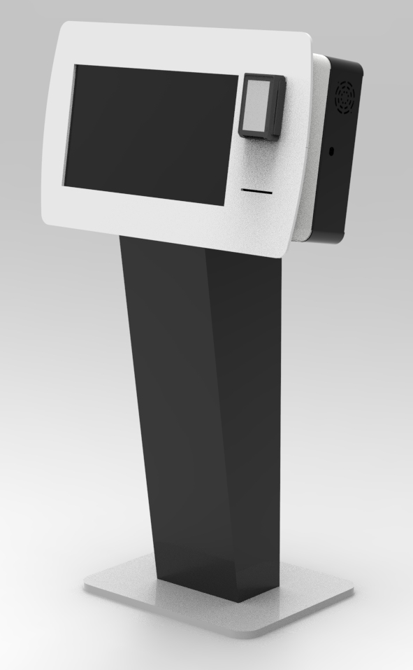
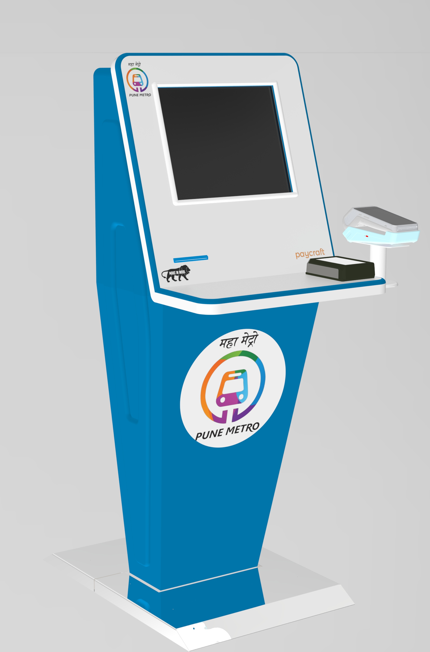
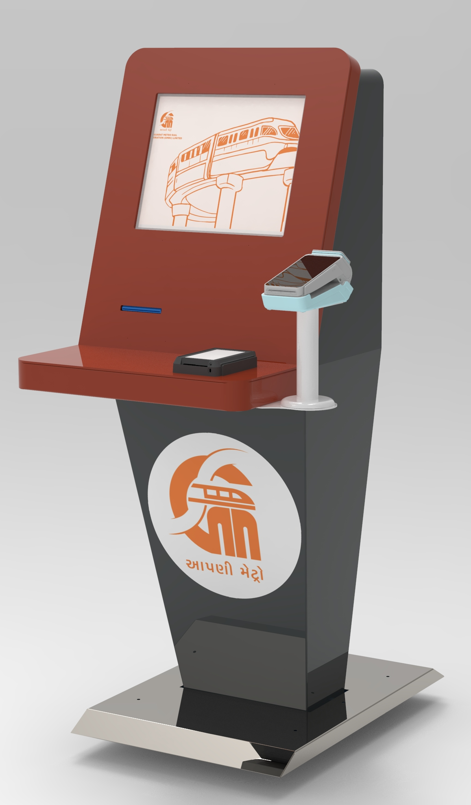
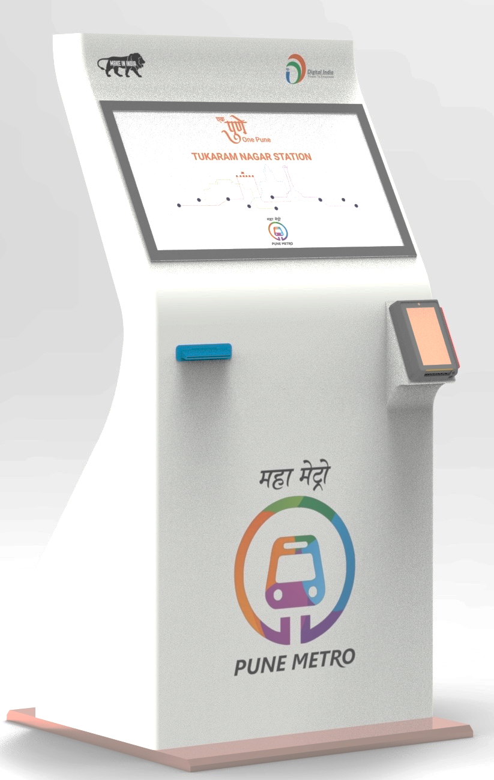
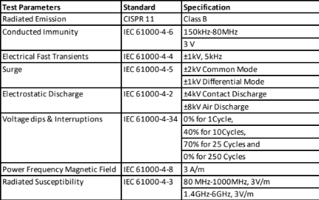
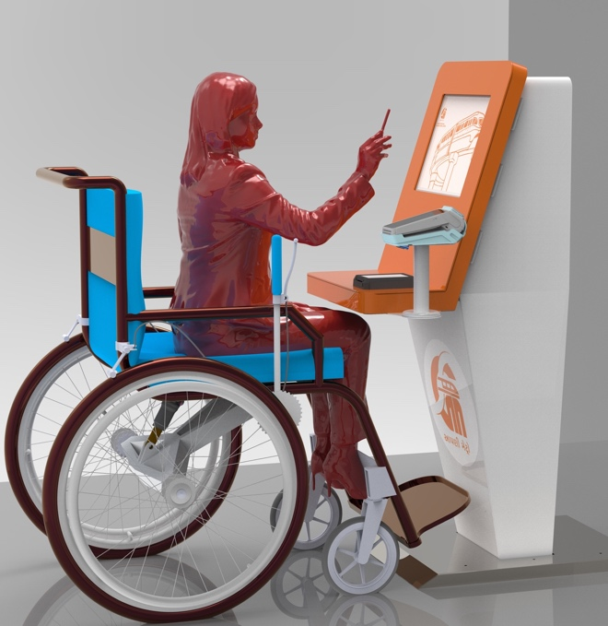
Other Design Options
Compliance
- TUV tested and Certified
- IP52 certified

SUPPORT AVAILABLE

Technical Support
Installation and Setup
Maintenance
Application Support
Hardware Support
Integration Support
Software Partners

Accessibility and Compliances
Material Enclosure - AISI 304 (IS 6911: 304) SS material
Weight - 70 +/- 20 Kg
Max Dimensions (W x D x H) - W–530 mm, D–600 mm, H–1450mm
Access - Front access
Ingress protection - IP52
Power Input - AC230V, 50Hz
Power consumption - Max – 150W
Operating Temperature - 0~50°C
Storage Temperature - -10~65°C
Humidity (no condensing) - Min 0%, Nominal 65%, Max 90%
Internal Ventilation- Cooling Fan
Communication - LAN and WiFi (optional)

