
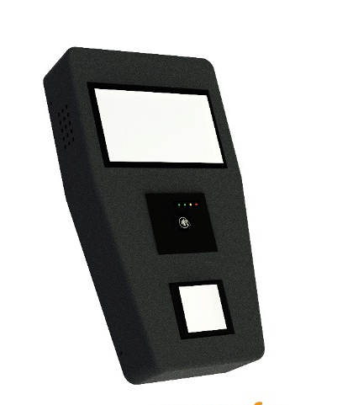
Fare Collection Validator – AUVAL04
- High Definition 7 Inch display

- Android Operating System

- Accepts Banking Cards

- Accepts RFID Cards / NFC Phone

- QR Code Reader

- Emergency Control

- Remote Device and Content Management
Product Datasheet – AUVAL Series
Connectivity Options
Connectivity over LAN, Wi-Fi or Bluetooth.
Separate secure communication channel for sensitive card data

Security Options
EMV certified hardware with support for Mastercard, Visa, RuPay, Amex and others

Integration Options
Designed to integrate with any Turnstile hardware designs and multiple AFCS system backend on standard integration protocols.
The validator comes with various customization options of size, material and form factor. Aumnatic shall provide complete support during software development and post deployment support.
AUVAL04 is Automatic Gate or Access control Turnstile Validator which can accept various forms of validation like QR Code (Paper or Mobile), Smart Card, Smart Wearables, Smart Phones and Banking Cards.

It is suitable for Automatic Fare Collection System as well as building access control systems. The smart mechanical design helps the support executive achieve a very aggressive MTTR (Mean Time To Recovery) of less than 10 minutes. The special snap-in and snap-out feature helps the support executive to meet the Service Levels easily.

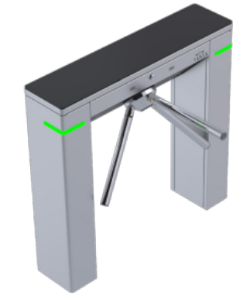
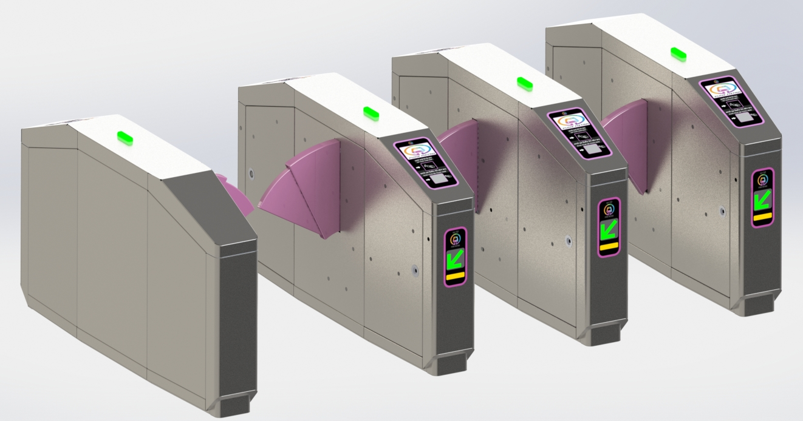
Product Datasheet – AUVAL04
Dimension: 375 X 205 X 65 (mm) – customization available
Material – MS / SS / ABS options
Validation Media: QR Code; Mastercard, Visa, Rupay, Mifare, Desfire
Mounting Provisions: Customized options available
Operating Temperature: -20°C to 60°C
Storage Temperature: -40°C to 70°C
Humidity: 5% to 95%, non-condensing
Operating System: Android 11 and above and Linux
SAM Options: Upto 4 SAM
Communication: Ethernet, WI-Fi, Bluetooth, RS232
Active Screen Size: 7 inch Diagonal with Capacitive Touch Panel
QR Code Reader: 752X480 CMOS with 38.3mm X 60.4mm scan window

Detailed specification of each component can be shared on request. Various customization options are available based on the specific requirement and size of the Turnstile top cover and installation provisions.
Installation Examples
Specifications

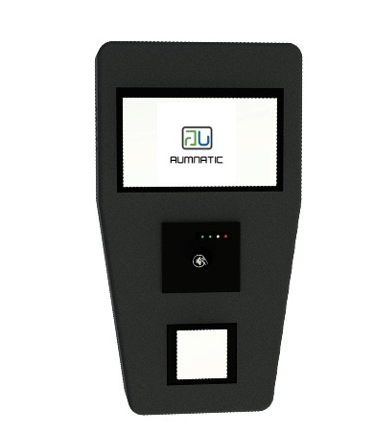
SUPPORT AVAILABLE

Technical Support
Installation and Setup
Maintenance
Application Support
Hardware Support
Integration Support
Software Partners

